**CS2023 - Data Structures and Algorithms**

**In-class Lab Exercise**

Week 4

**By: Sajeev Kugarajah (210554M)**

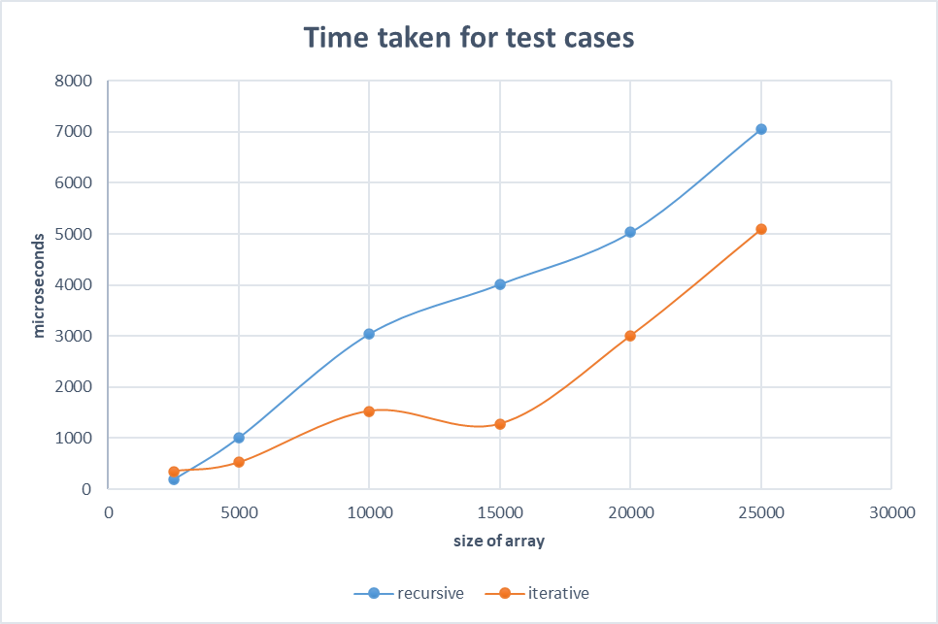**Time plot graph**

**Discussion**

The above graph shows that iterative merge sort is taking lesser time for sorting an array than recursive merge sort for larger array cases. But for small arrays, the recursive algorithm is taking lesser time according to the plot.

The recursive algorithm is slower for larger arrays because, in the case of larger arrays, the recursive algorithm requires more overhead and an additional function stack to manage the recursion.

Theoretically, we know that time complexities for both algorithms are O(n(logn)) and we can verify that using the growth of the plot with the size of the array

So we can conclude that the iterative merge sort algorithm is better for non-nested larger arrays due to its low overhead, and recursive merge sort is better for smaller arrays, and nested arrays.